Getting the database up and running

In the project folder there is a folder called database stuff

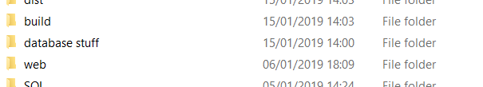

In netbeans, in the services tab right click on the java db link under databases

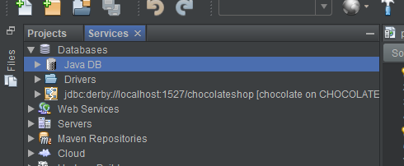

Click properties and change the two locations to the matching folders within database stuff

